**WEEK 6 – REACTJS**

**ASSIGNMENT 1:** Create a new React Application with the name “myfirstreact”, Run the application to print “welcome to the first session of React” as heading of that page.

App.js

function App() {

  return (

    <div>

      <h1>Welcome to the first session of React</h1>

    </div>

  );

}

export default App;

Output:

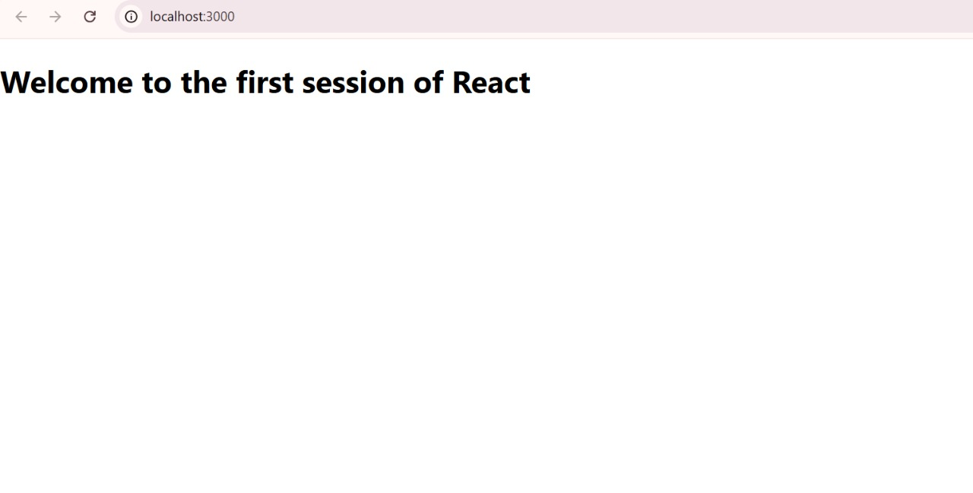

**ASSIGNMENT 2:** Create a react app for Student Management Portal named StudentApp and create a component named Home which will display the Message “Welcome to the Home page of Student Management Portal”. Create another component named About and display the Message “Welcome to the About page of the Student Management Portal”. Create a third component named Contact and display the Message “Welcome to the Contact page of the Student Management Portal”. Call all the three components.

About.js

import React, { Component } from 'react';

class About extends Component {

  render() {

    return (

      <div>

        <h3>Welcome to the About page of the Student Management Portal</h3>

      </div>

    );

  }

}

export default About;

Home.js

import React, { Component } from 'react';

class Home extends Component {

  render() {

    return (

      <div>

        <h3>Welcome to the Home Page of Student Management Portal</h3>

      </div>

    );

  }

}

export default Home;

Contact.js

import React, { Component } from 'react';

class Contact extends Component {

  render() {

    return (

      <div>

        <h3>Welcome to the Contact page of the Student Management Portal</h3>

      </div>

    );

  }

}

export default Contact;

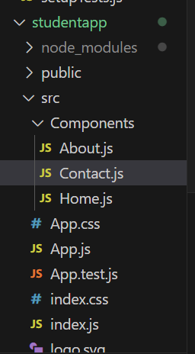

Output:

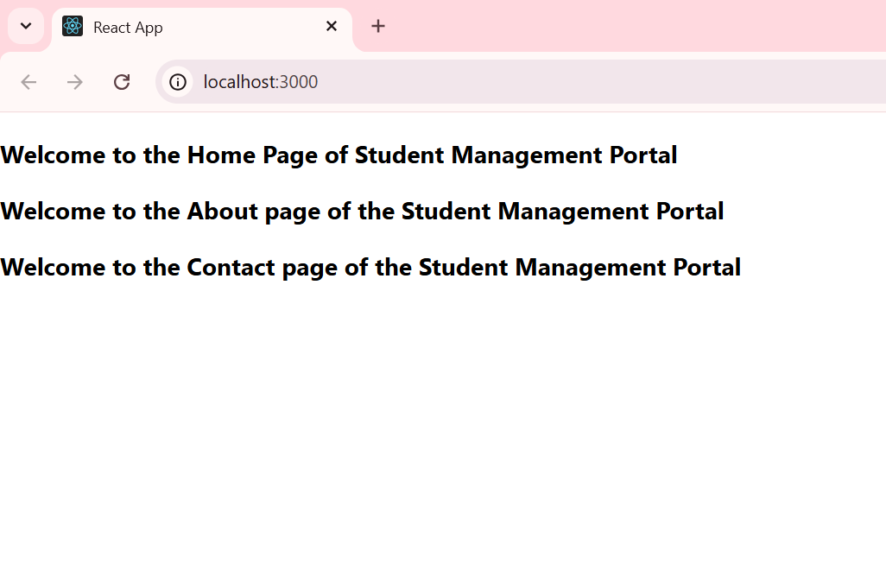

**ASSIGNMENT 3:** Create a react app for Student Management Portal named scorecalculatorapp and create a function component named “CalculateScore” which will accept Name, School, Total and goal in order to calculate the average score of a student and display the same.

CalculateScore.js

import '../Stylesheets/mystyle.css';

export const CalculateScore = ({ Name, School, total, goal }) => {

  const percentToDecimal = (decimal) => {

    return (decimal * 100).toFixed(2) + '%';

  };

  const calcScore = (total, goal) => {

    return percentToDecimal(total / goal);

  };

  return (

    <div className="formatstyle">

      <h1 style={{ color: 'brown' }}>Student Details</h1>

      <div className="Name"><b>Name:</b> {Name}</div>

      <div className="School"><b>School:</b> {School}</div>

      <div className="Total"><b>Total:</b> {total}</div>

      <div className="Score"><b>Score:</b> {calcScore(total, goal)}</div>

    </div>

  );

};

App.js

import React from 'react';

import { CalculateScore } from './Components/CalculateScore';

function App() {

  return (

    <div>

      <CalculateScore

        Name="Steeve"

        School="DNV Public School"

        total={284}

        goal={3}

      />

    </div>

  );

}

export default App;

mystyle.css

.Name

{

    font-weight:300;

    color:blue;

}

.School

{

    color:crimson;

}

.Total

{

    color:darkmagenta;

}

.formatstyle

{

    text-align:center;

    font-size:large;

}

.Score

{

    color:forestgreen;

}

Output:

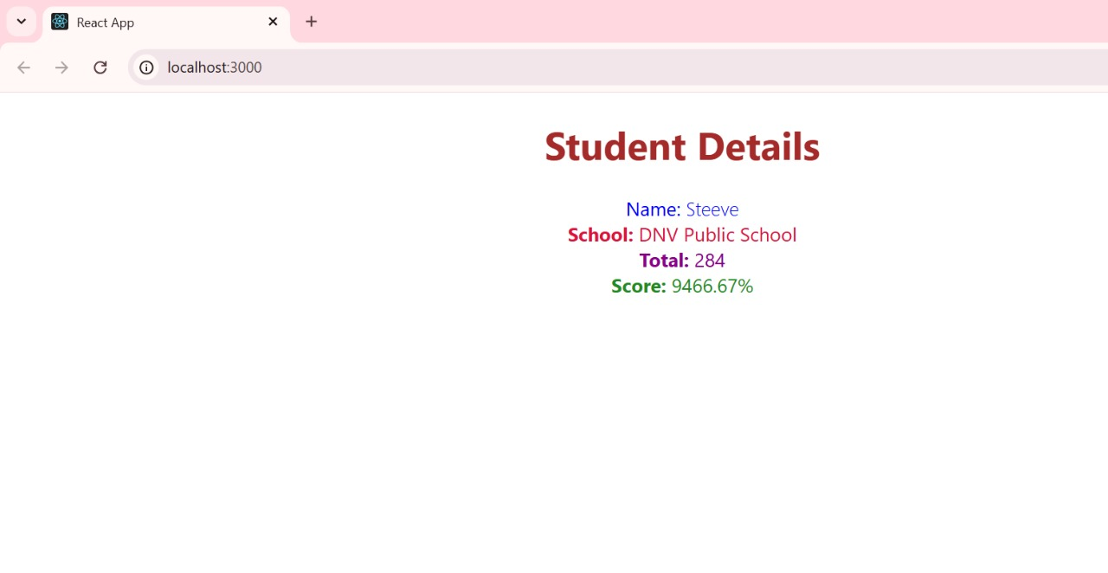

**ASSIGNMENT 4:**

Post.js

class Post

{

    constructor(id, title,body)

    {

        this.id=id;

        this.title=title;

        this.body=body;

    }

}

export default Post;

Posts.js

// src/Posts.js

import React from 'react';

import Post from './Post';

class Posts extends React.Component {

  constructor(props) {

    super(props);

    this.state = {

      posts: [],

      visibleCount: 10  // show 10 posts initially

    };

  }

  loadPosts() {

    fetch('https://jsonplaceholder.typicode.com/posts')

      .then(response => response.json())

      .then(data => {

        const postList = data.map(p => new Post(p.id, p.title, p.body));

        this.setState({ posts: postList });

      })

      .catch(error => {

        console.error('Error fetching posts:', error);

        alert('Failed to load posts.');

      });

  }

  componentDidMount() {

    this.loadPosts();

  }

  componentDidCatch(error, info) {

    alert('An error occurred: ' + error.toString());

    console.error('Error caught in component:', error, info);

  }

  handleViewMore = () => {

    this.setState(prevState => ({

      visibleCount: prevState.visibleCount + 10

    }));

  };

  render() {

    const { posts, visibleCount } = this.state;

    const visiblePosts = posts.slice(0, visibleCount);

    return (

      <div style={{ padding: '20px', fontFamily: 'Arial' }}>

        <h1 style={{ textAlign: 'center' }}>All Blog Posts</h1>

        {visiblePosts.map(post => (

          <div key={post.id} style={{ marginBottom: '20px', borderBottom: '1px solid #ccc' }}>

            <h2>{post.title}</h2>

            <p>{post.body}</p>

          </div>

        ))}

        {visibleCount < posts.length && (

          <div style={{ textAlign: 'center' }}>

            <button onClick={this.handleViewMore} style={{ padding: '10px 20px', fontSize: '16px' }}>

              View More

            </button>

          </div>

        )}

      </div>

    );

  }

}

export default Posts;

App.js

// src/App.js

import React from 'react';

import './App.css';

import Posts from './Posts';

function App() {

  return (

    <div className="App">

      <Posts />

    </div>

  );

}

export default App;

App.css

/* src/App.css */

body {

  margin: 0;

  padding: 0;

  background-color: #f8f8f8;

}

button {

  background-color: #007bff;

  color: white;

  border: none;

  border-radius: 5px;

  cursor: pointer;

}

button:hover {

  background-color: #0056b3;

}

Output:

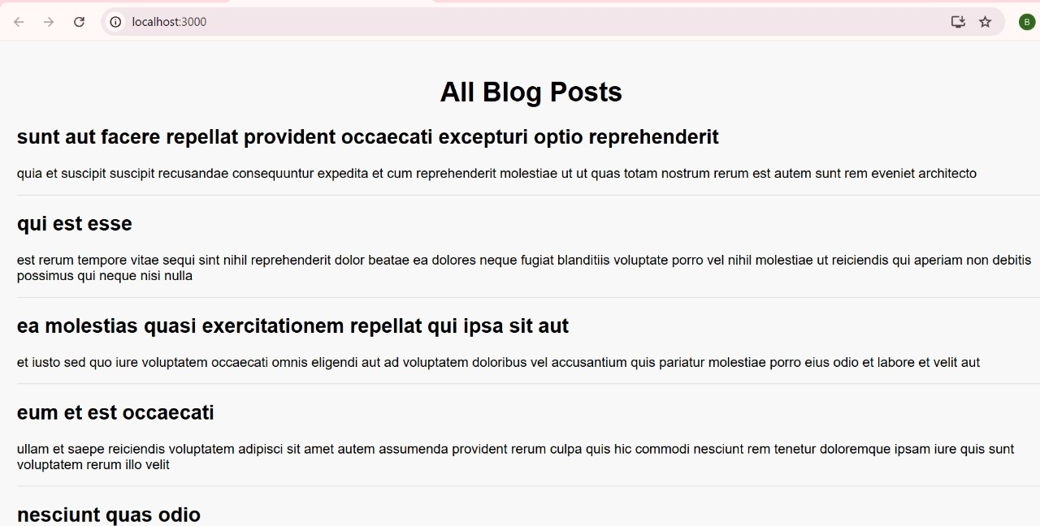

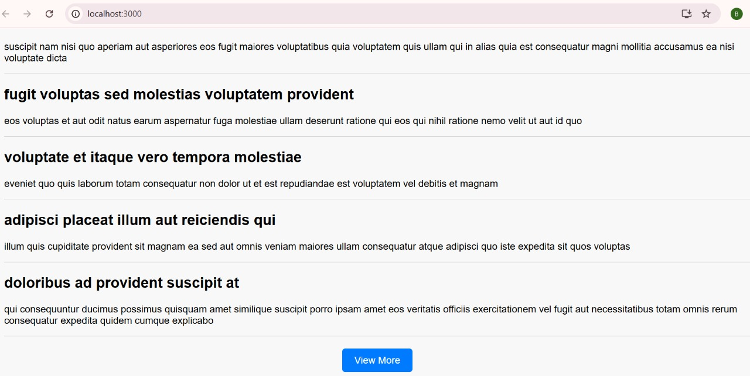

**ASSIGNMENT 6:** My Academy team at Cognizant want to create a dashboard containing the details of ongoing and completed cohorts. A react application is created which displays the detail of the cohorts using react component. You are assigned the task of styling these react components.

App.js

import React from 'react';

import CohortDetails from './CohortDetails';

function App() {

  return (

    <div className="App">

      <CohortDetails />

    </div>

  );

}

export default App;

CohortDetails.js

import React from 'react';

import styles from './CohortDetails.module.css';

const CohortDetails = () => {

  const cohorts = [

    {

      id: 'INTADMDF10',

      name: '.NET FSD',

      startedOn: '22-Feb-2022',

      status: 'Scheduled',

      coach: 'Aathma',

      trainer: 'Jojo Jose'

    },

    {

      id: 'ADM21JF014',

      name: 'Java FSD',

      startedOn: '10-Sep-2021',

      status: 'Ongoing',

      coach: 'Apoorv',

      trainer: 'Elisa Smith'

    },

    {

      id: 'CDBJF21025',

      name: 'Java FSD',

      startedOn: '24-Dec-2021',

      status: 'Ongoing',

      coach: 'Aathma',

      trainer: 'John Doe'

    },

    {

      id: 'INTADMJF12',

      name: 'Java FSD',

      startedOn: '22-Feb-2022',

      status: 'Scheduled',

      coach: 'Ibrahim',

      trainer: 'To Be Assigned'

    },

    {

      id: 'CDE22JF011',

      name: 'Java FSD',

      startedOn: '24-Dec-2021',

      status: 'Ongoing',

      coach: 'Apoorv',

      trainer: 'Emma Swan'

    },

    {

      id: 'INTADMDF09',

      name: 'Dataware Housing',

      startedOn: '22-Feb-2022',

      status: 'Scheduled',

      coach: 'Aathma',

      trainer: 'Babjee Rao'

    },

    {

      id: 'ADM22DF001',

      name: '.NET FSD',

      startedOn: '10-Sep-2021',

      status: 'Ongoing',

      coach: 'Ibrahim',

      trainer: 'Marie Curie'

    }

  ];

  return (

    <div>

      <h2>Cohorts Details</h2>

      {cohorts.map((cohort, index) => (

        <div key={index} className={styles.box}>

          <h3 style={{ color: cohort.status === 'Ongoing' ? 'green' : 'blue' }}>

            {cohort.id} - {cohort.name}

          </h3>

          <dl>

            <dt>Started On</dt>

            <dd>{cohort.startedOn}</dd>

            <dt>Current Status</dt>

            <dd>{cohort.status}</dd>

            <dt>Coach</dt>

            <dd>{cohort.coach}</dd>

            <dt>Trainer</dt>

            <dd>{cohort.trainer}</dd>

          </dl>

        </div>

      ))}

    </div>

  );

};

export default CohortDetails;

CohortDetails.module.css

.box {

  width: 300px;

  display: inline-block;

  margin: 10px;

  padding: 10px 20px;

  border: 1px solid black;

  border-radius: 10px;

}

dt {

  font-weight: 500;

}

Output:

